27 April 2007 The Weekly Bulletin of Rotary Club of Kathmandu Mid-Town Bc # 43 of 2006-07
Rotary Club of Kathmandu Mid-Town
Breakfast Chatter
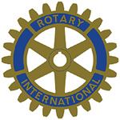



District : 3290 Web: www.rotarymidtown.org.np Club Id : 26776

APRIL IS THE MAGAZINE MONTH
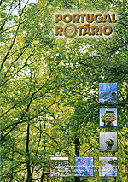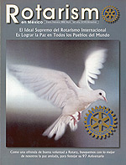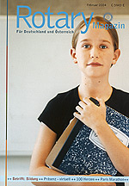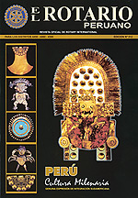
Every two years all regional magazine editors are invited to participate in the Regional Magazine Editors Seminar. The three-day meeting provides a forum for the editors to meet and discuss their common problems and concerns as well as the opportunity for RI to give them directions and guidance on how best to fulfill their Rotary communications responsibilities.

Club Assembly in session
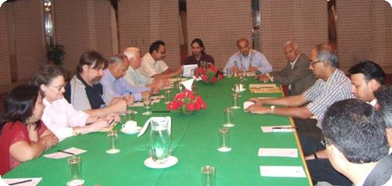
The Club had its 5th club assembly of the Year 2006-07 on 20 April 2007.

Weekly Meetings and Programs :
Date | Program/Speaker | Program/Topics of Presentation
27 April 2007 | Mangal Man Shakya | Illegal wildlife trade
4 May 2007 | Dr Dwarika N Dhungel | Governance in the working of political parties
11 May 2007 | Gyanendra Lal Pradhan | Hydropower
18 May 2007

Club Picnic :
The Club is going to have its long-awaited picnic finally on Saturday, 28 April 2007.
The venue is at the proposed Rotary Peace Park site near SKM Hospital, Sankhu.

Friday, 27 April :
Mr. Mangal Man Shakya, environmental journalist, coordinator/chairman of Wildlife Watch Group (WWG) will be talking on illegal trade in tiger parts and other species. The long Indo-Nepal border is highly porous and poorly controlled, making it an ideal trade route for wildlife products, especially such high-value products as tiger and leopard parts. He will be throwing lights also on links of this trade to Tibet.

Cremains: remains after cremation :
Ashes to ashes, dust to diamonds; sounds macabre ? It's biz. Britons are turning to making cremated remains into gemstones, paintings or coral reefs: British customers are flocking to an American company which has developed the technology to turn human remains into diamonds.
Life Gem Memorials has patented a 16-week process that involves purifying ash at 3,000 degree C before it is further heated and pressurised into a diamond. The diamonds range in cost from £ 2500 to £ 14,000. In Europe, they are certified by the European Gemological Laboratory, which examines gems from across the world. The company has already taken a flood of inquiries from Britons who want to turn their relatives into diamonds. "The average person has enough carbon in him to produce between 50 to 100 diamonds," said Amanda Leesburgh, a company spokesperson. "It's a simple process. We're basically taking the fact that all living creatures are carbon-based, and so are diamonds. I think people across the world like the idea of wearing a diamond that is very much part of their loved one."
Source: The Himalayan Times

On Lighter Side : Click at the figure ⇩


When we work on small projects that help only a few people, it can be hard to step back and see how we really are changing the world. It can be difficult to see how recycling a newspaper or a plastic container, walking instead of driving, or using less water can really bring a better and healthier tomorrow. But if many people make them together, those small changes will make an enormous difference to our children and grandchildren.
RI President William B. Boyd

27 April 2007 The Weekly Bulletin of Rotary Club of Kathmandu Mid-Town Bc # 43 of 2006-07

Editor: RR Shrestha, Club Service Director email: rryes@wlink.com.np

